
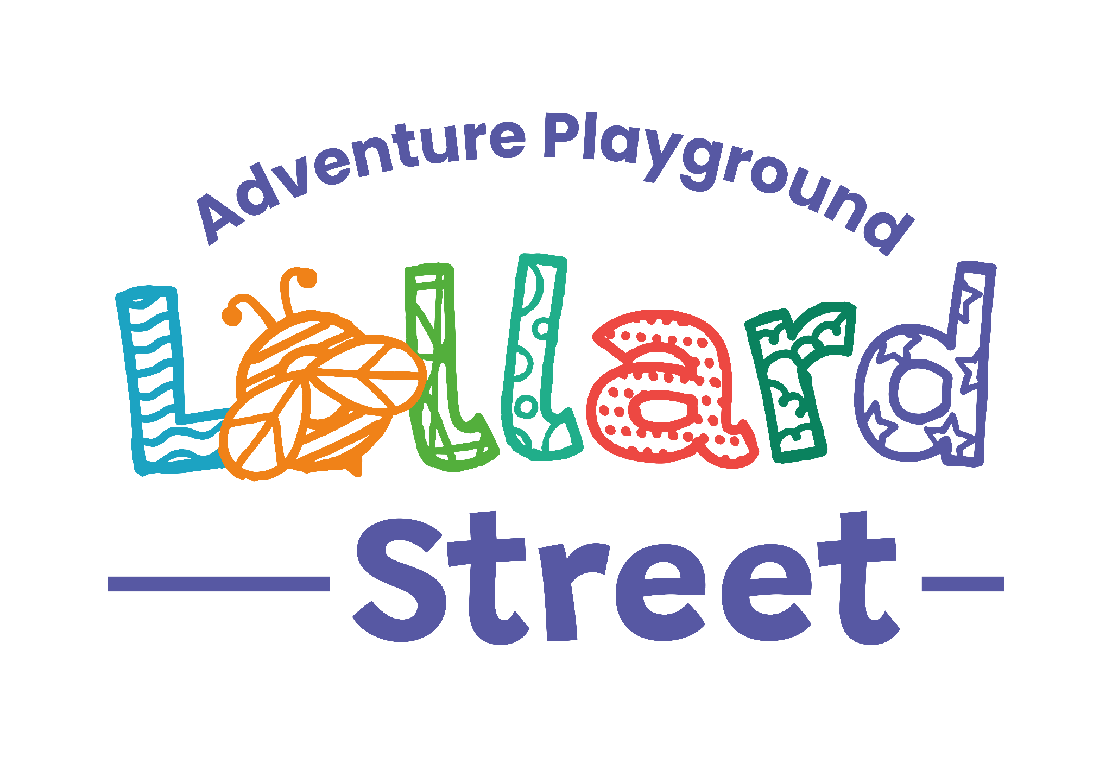

The Kennington Association Limited
TO ENQUIRE ABOUT BOOKING A PARTY, PLEASE EMAIL office@lollardstplay.org.uk. IF YOUR CHOSEN DATE IS AVAILABLE YOU WILL THEN BE ASKED TO FILL IN AND RETURN THIS FORM
Party Hires Form and Conditions of Hire Agreement
Data Protection: Signing this form implies that you give permission for us to hold information from the form on manual and computer files. We keep this information for the Kennington Association’s purposes only and we will not disclose any details to other people or organisations without your permission. Signing of this booking form implies you have read and understood the Kennington Association’s Conditions of Hire for the Use of Building/Resources, and that you agree to keep within the terms of the Agreement. It implies you agree with the aims of the Kennington Association and the values they stand for.
- Hirer Details
Full Name
Address
Phone Number
Email Address
- Event Details
Start Date
End Date
Start Time
End Time
Will you be using the fire pit?
Estimated number adults attending
Estimated number children attending
- Areas Requested
What areas of the playground will you be using? (Tick all that apply) | Anna Tapsell Building  Prefab  Kitchen  Small pitch (large is unavailable)  Outdoor site, including garden
- Equipment Requested
What playground equipment will you be using? (Tick all that apply)  USE OF LSAP EQUIPMENT IS AT RISK OF HIRING PARTY | Boarder swings  Zipline  Swings below coloured roof  Wooden structure  Slides  Boat
- Hire Fees & Payment
- Hire cost: £65 per hour
- Minimum booking: 3 hours
- Deposit: £100 (refundable subject to conditions)
- Hire fee must be paid at least 48 hours before the date of the hire

Payment methods
☐ Bank transfer ☐ Cash or cheque
Bank details
Account name: The Kennington Association Ltd
Account no: 12887434
Sort code: 23-05-80
Reference: Please use your name and booking date as the payment reference

Terms and Conditions of Hire
Please read the Conditions of Hire below and sign to confirm your agreement.
Thank you for hiring Lollard Street Adventure Playground. The playground and associated facilities are available for children's events at a rate of £65 per hour, with a minimum booking of three hours.
By signing this agreement, you accept the following terms and conditions.
1. Supervision and Responsibility
- Children under six years of age must be supervised by a responsible adult at all times.
- All children attending the event remain the responsibility of their parents, carers, or the hirer.
- A member of staff will be present to open the site at the start of the session and secure it at the end. However, staff are not responsible for supervising the event or ensuring the safety of children using the playground equipment.
- The Kennington Association accepts no liability for the health, safety, or wellbeing of children or adults attending the event.
- The adventure playground is designed to provide challenging and adventurous play opportunities for children aged six and over. Hirers are responsible for ensuring appropriate supervision of children using the equipment and structures.
- A staff member on duty will be First Aid trained and able to provide basic first aid assistance if required.

2. Use of the Site
The following rules apply at all times:
- No dogs or other animals are permitted on site.
- Smoking and the consumption of alcohol are strictly prohibited anywhere on the site, including all buildings and storage containers.
- The main entrance gates must remain clear of vehicles at all times to allow access for emergency services.
- Hirers may use the kitchen facilities and equipment; however, children must not enter the kitchen unsupervised.
- At the end of the hire period, all equipment used must be returned to its original location and the site left clean and tidy, in the same condition in which it was found. Cleaning products are available in the kitchen and store cupboard, and staff will show you where these are located.
3. Hire Fees and Payment
- The hire fee is £65 per hour, with a minimum booking duration of three hours.
- A booking deposit is required to secure the reservation.
- The full hire fee must be paid no later than 7 days before the event date.
- Payment must be received before the day of the event.

Payment Methods
Bank Transfer (BACS)
Account Name: The Kennington Association Ltd
Account Number: 12887434
Sort Code: 23-05-80
Please use your name and booking date as the payment reference.
Cheque Payments
Cheques should be made payable to The Kennington Association Ltd.
4. Security Deposit
A refundable £100 security deposit is required in addition to the hire fee.
The deposit provides protection against loss, damage, additional cleaning, or other costs incurred as a result of the hire. The deposit will be returned within one week of the event, less any deductions where applicable.
Please note that your liability is not limited to the value of the deposit. The Kennington Association reserves the right to recover the full cost of any loss, theft, damage, misuse of facilities, or unauthorised use of the premises.
Where deductions are proposed, you will be notified as soon as possible and given the opportunity to discuss the matter with the Director or Board Treasurer before the balance of the deposit is returned.
Hirers are permitted access to the venue 30 minutes before the booking start time for set-up only, at no additional charge.
Deductions from the Deposit
Deductions may be made in the following circumstances:
- Failure to vacate the premises at the agreed time – up to £100.
- Failure to leave the site clean and tidy – up to £100.
- Use of facilities, equipment, or materials not included in the booking agreement – up to £100.
- Use of the site for purposes other than those agreed – costs not limited to the deposit value.
- Making unauthorised charges for use of the premises or facilities – costs not limited to the deposit value.
- Damage to, loss of, or theft of LSAP/Kennington Association property – charged at full replacement or repair cost.
5. Access on the Day
If you experience any problems accessing the site or expect to arrive late, please contact: 07851943612
6. Cancellation and Refunds
If The Kennington Association is unable to provide the booked service, a full refund of the hire fee will be issued or a credit offered towards a future booking.
If you cancel your booking:
- More than 7 days before the event: Full refund of hire fees less a £25 administration fee.
- Less than 7 days before the event: Up to 50% refund of hire fees, less a £25 administration fee.

7. Complaints and Feedback
We welcome both compliments and constructive feedback.
If you have any concerns during your booking, please raise them initially with the member of staff on duty. If the matter cannot be resolved informally, please contact:
Faith Taylor, Director
Telephone: 020 7793 9592 or 07851943612
Information about our formal complaints procedure is available on request.
Declaration
I have read and understood these Terms and Conditions of Hire and agree to comply with them. I accept full responsibility for the behaviour, safety, and wellbeing of all children and adults attending my event.
Name: ___________________________________________
Signature: ________________________________________
Date: _____________________________________________

