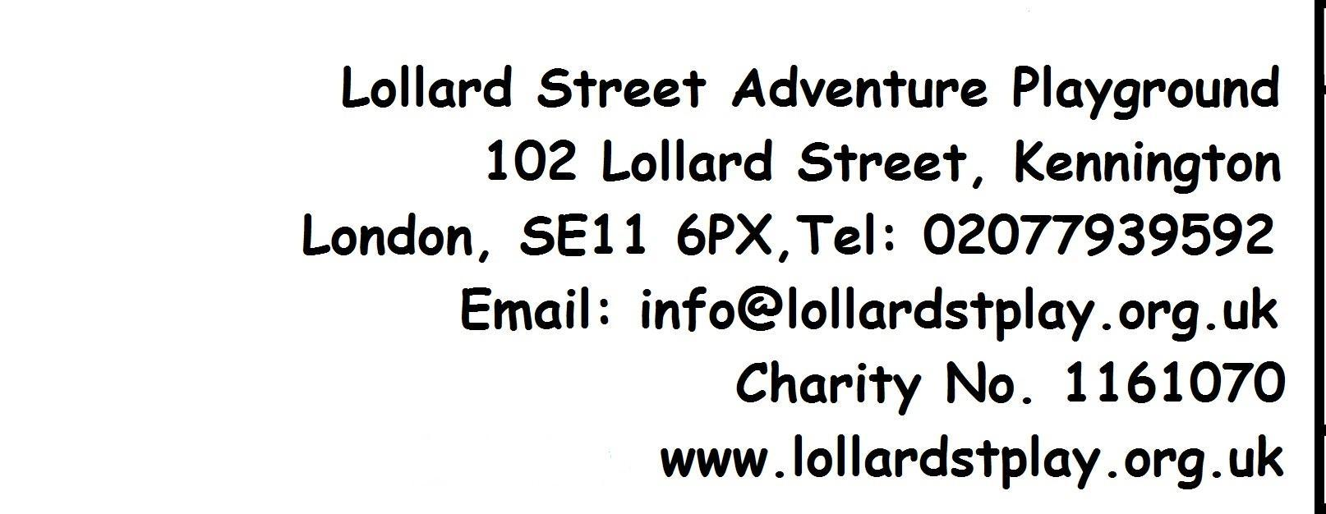
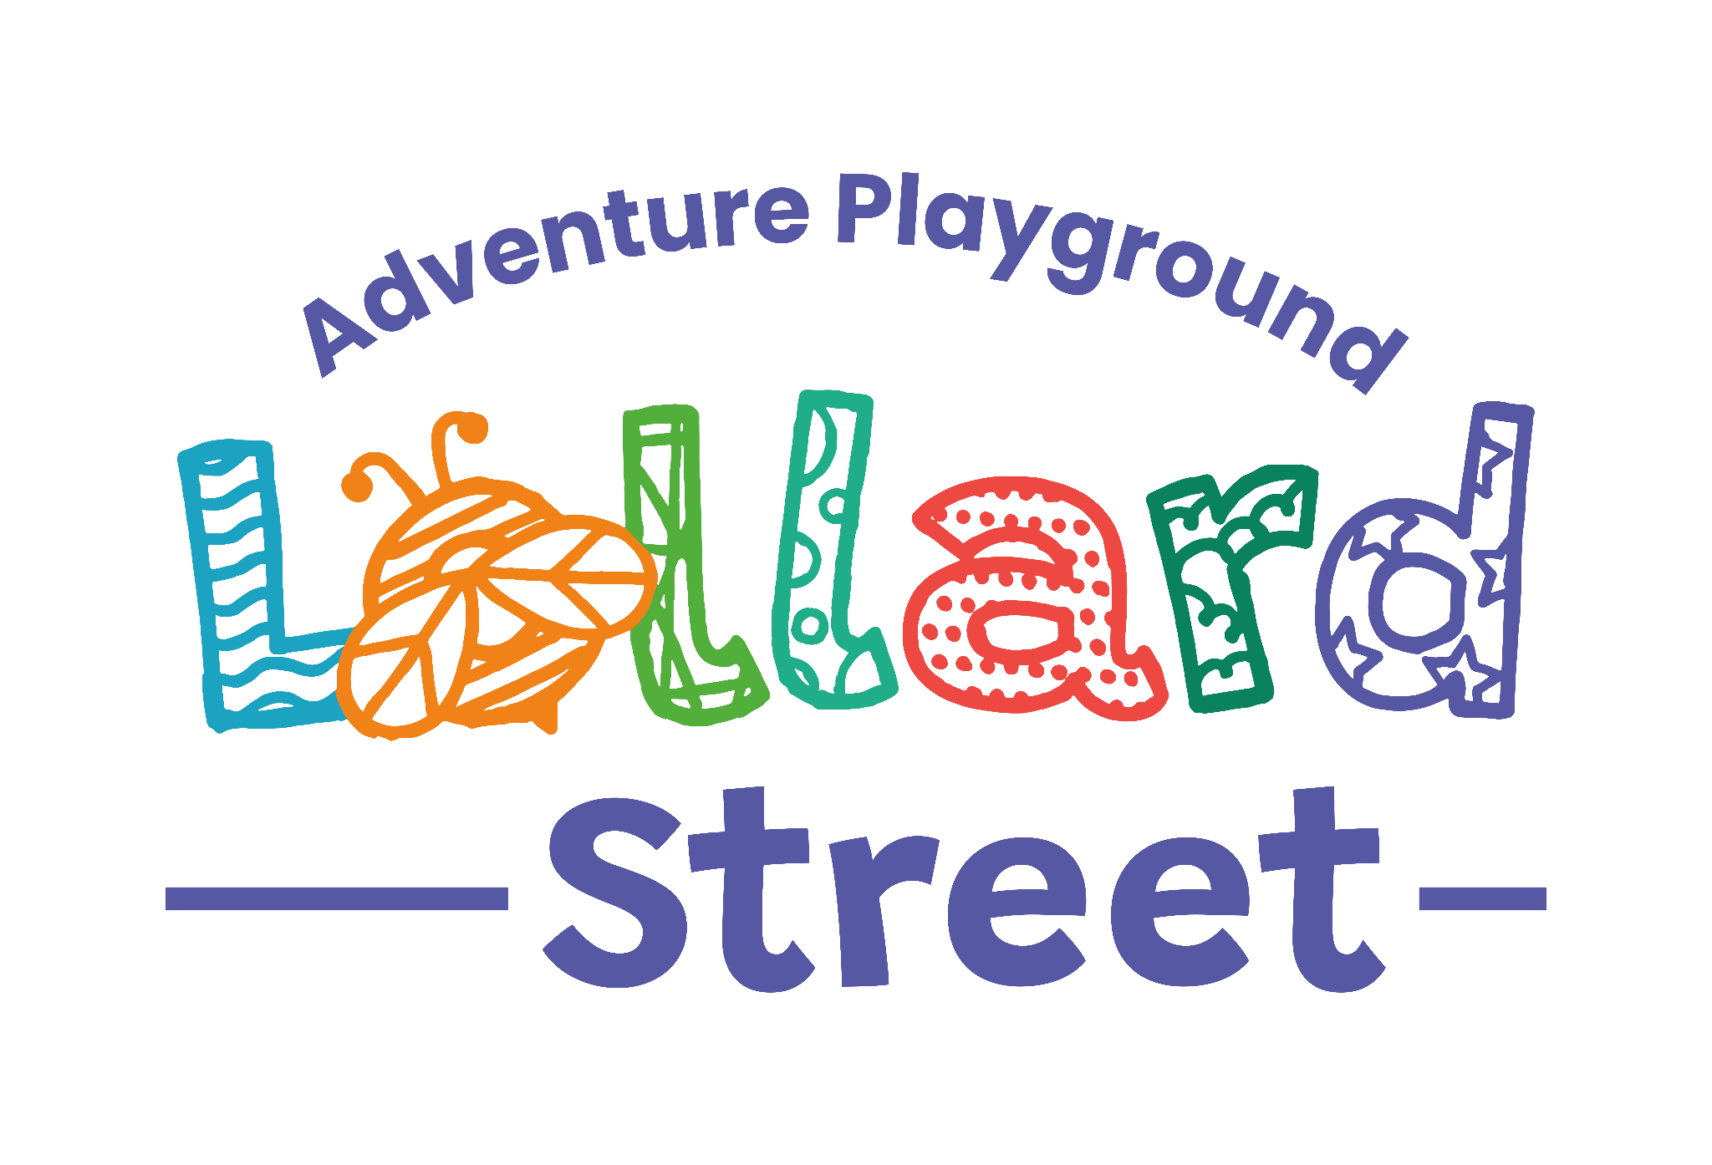

Party Hire Booking Form & Conditions
To enquire about booking a party, please email office@lollardstplay.org.uk to check availability.
If your chosen date is available, you will be asked to complete and return this form.
1. Hirer Details
Full Name:
Address:

Phone Number:
Email Address:

2. Event Details
Type of Event

Start Date
End Date

Start Time
End Time
Will you use the fire pit? | ☐ Yes ☐ No

Estimated Number of Adults Attending
Estimated Number of Children Attending

3. Areas Requested (tick all that apply)
☐ Prefab
☐ Kitchen
☐ Small pitch (large pitch unavailable)
☐ Playground/Garden

4. Hire Fees & Payment
Hire cost: £65 per hour
Minimum booking: 3 hours
Deposit: £100 (refundable subject to conditions)
Hire fee must be paid at least 7 days before the event.
Payment methods
☐ Bank transfer
☐ Cash or cheque
Bank details
Account name: The Kennington Association Ltd
Account no: 12887434
Sort code: 23-05-80
Reference: Name and date of booking

5. Deposit Conditions
The £100 deposit may be reduced or withheld if:
Premises not vacated at agreed time (up to £100)
Site not left clean and tidy (up to £100)
Unauthorised equipment or facilities used (up to £100)
Site used for purposes not agreed (unlimited liability)
Unauthorised charges made for use of site (unlimited liability)
Damage or theft of property (charged at replacement cost)
Deposits are returned within one week (less deductions if applicable). Hirers will be informed of any deductions and may discuss them with management before return.

6. Cancellation Policy
7+ days’ notice: Full refund minus £25 admin fee
Less than 7 days: Up to 50% refund minus £25 admin fee
If the venue cancels, a full refund or credit will be offered.

7. Access on the Day
If you are late or have access issues, call:
07473 09275
You may arrive 30 minutes before your booking time for setup (included in hire fee).

8. Important Site Rules
- By signing this form, you agree:
- Children under 6 must be supervised at all times.
- All children must be supervised by their parents/carers.
- A staff member will open/lock the site but is not responsible for supervision.
- The Association accepts no liability for attendees’ safety.
- No smoking, alcohol, dogs, or animals on site.
- Access gates must remain clear for emergency vehicles.
- Leave the site as you found it; cleaning materials are provided.
- Playground equipment is designed for adventurous play for children 6+.
- Children must not enter the kitchen unsupervised.
- Staff on duty will be First Aid trained.

9. Data Protection
Signing this form confirms that you consent to The Kennington Association holding your information for administrative purposes only. Your data will not be shared without permission.

10. Agreement & Signature
I confirm that:
I have read and understood the Conditions of Hire.
I agree to comply with all terms.
I accept full responsibility for the behaviour, safety, and wellbeing of all attendees.
Signed: ____________________________
Print Name: ________________________
Date: ______________________________

