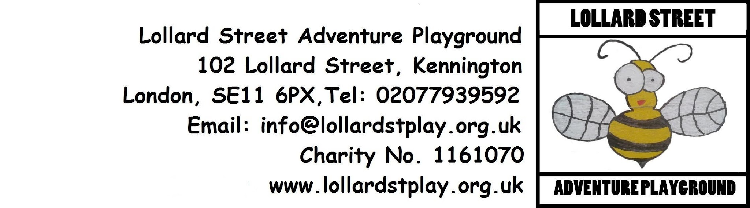
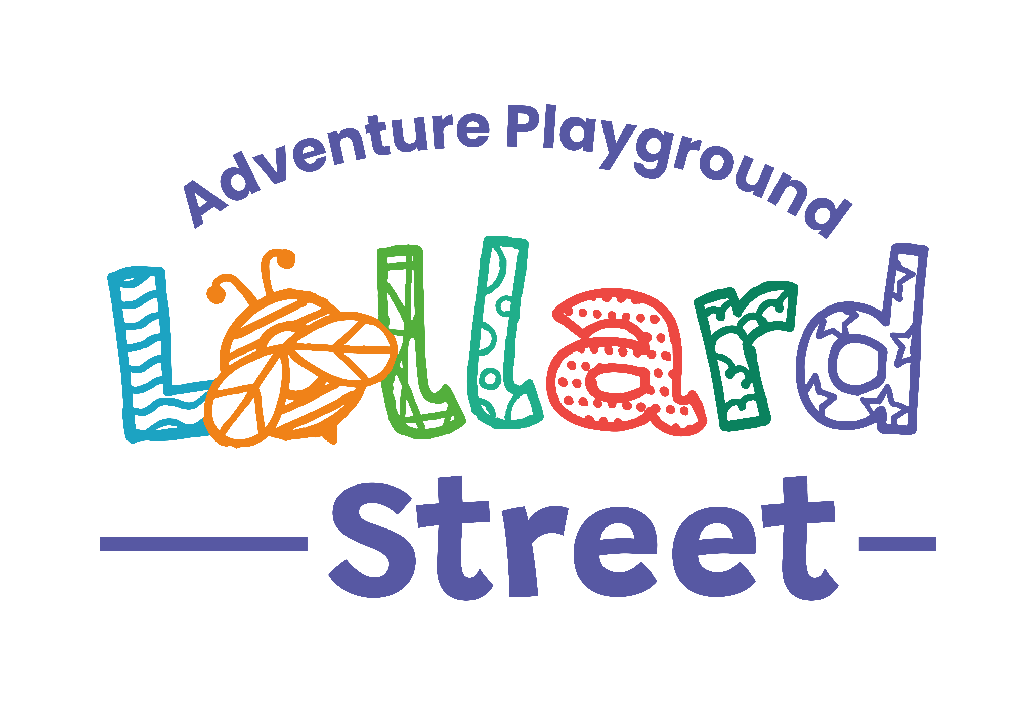
Indoor Room Hire Booking Form & Terms and Conditions

Thank you for your interest in hiring one of our indoor spaces. Please complete this form and read the Terms and Conditions before signing.

1. Hirer Details
Name: _____________________________________________________________
Organisation (if applicable): ________________________________________
Address: ___________________________________________________________
Telephone: _________________________________________________________
Email: ______________________________________________________________

2. Booking Details
Date of Hire: ________________________________________________________
Start Time: _________________________________________________________
Finish Time: ________________________________________________________
Estimated Number of Attendees: _____________________________________

3. Space Required
Please tick the space you wish to hire:
Library
☐ Private Hire / Business – £40 per hour
☐ Charity / Community Project – £25 per hour
Includes access to:
- Kettle
- Fridge
- Sofa
- Adjustable table and chairs
- Microwave
- Books and toys
- Tea and coffee facilities

Music Studio / Pool Room
☐ Private Hire / Business – £25 per hour
☐ Charity / Community Project – £20 per hour
Special musician rate: £40 for a 3-hour practice session
Includes access to:
- Pool table
- Electric drum kit
- PA system
- Microphones
- Electric piano
Additional equipment available:
Other instruments and amplifiers can be hired for an additional £20 per hour.
Additional equipment required?
☐ Yes ☐ No
If yes, please specify:
_______________________________________________________________________
Prefab
☐ Private Hire / Business – £40 per hour
☐ Charity / Community Project – £25 per hour
Includes access to:
- Crash mats
- Fully equipped kitchen
- Play materials

4. Hire Charges
Space |  | Private Hire / Business | Charity / Community Project
Library | £40 per hour |  | £25 per hour
Music Studio / Pool Room | £25 per hour |  | £20 per hour
Prefab | £40 per hour |  | £25 per hour
Total Hire Fee: £____________________

5. Payment Details
Payment must be received 48 hours before the date of hire.
Bank Transfer (BACS)
Account Name: The Kennington Association Ltd
Account Number: 12887434
Sort Code: 23-05-80
Please use your name and booking date as the payment reference.
Cheque Payment
Cheques should be made payable to The Kennington Association Ltd.
Payment method:
☐ Bank Transfer
☐ Cheque
☐ Cash

Terms and Conditions of Hire
- Use of the Premises
- Hirers are responsible for the conduct and safety of all attendees during the hire period.
- The premises must only be used for the purpose stated on this booking form.
- The hirer must ensure that the room and any equipment used are left clean, tidy, and in the same condition as found.
- Any damage, loss, or breakage must be reported immediately.
- No smoking is permitted anywhere within the buildings or grounds.
- Alcohol may only be consumed with prior written permission from The Kennington Association.
- Access is limited to the room(s) booked and agreed facilities only.
- Equipment and Facilities
- Equipment provided within each room must be used appropriately and safely.
- Additional instruments and amplifiers in the Music Studio are subject to additional charges and prior agreement.
- The Kennington Association accepts no responsibility for loss, theft, or damage to personal belongings brought onto the premises.
- Payment and Cancellation
- Full payment must be received before the date of hire.
- Cancellations made more than 7 days before the booking date will receive a refund less a £25 administration fee.
- Cancellations made less than 48 hours before the booking date may receive up to a 50% refund, less a £25 administration fee.
- If The Kennington Association is unable to provide the booked space, a full refund or alternative booking date will be offered.
- Health and Safety
- Fire exits and access routes must remain clear at all times.
- Hirers must comply with any instructions provided by staff regarding health and safety.
- Any accidents, incidents, or concerns must be reported to a member of staff immediately.
- Access and Support
If you experience any issues accessing the building on the day of your booking, please contact: 07851943612

- Data Protection
Signing this form confirms that you consent to The Kennington Association holding your information for administrative purposes only. We keep this information for the Kennington Association’s purposes only and we will not disclose any details to other people or organisations without your permission. Signing of this booking form implies you have read and understood the Kennington Association’s Conditions of Hire for the Use of Building/Resources, and that you agree to keep within the terms of the Agreement.

- Agreement & Signature
Declaration
I confirm that I have read and understood the Terms and Conditions of Hire and agree to comply with them. I accept responsibility for all persons attending during my booking and for any damage caused during the hire period.

Name: ___________________________________________
Signature: ________________________________________
Date: _____________________________________________

